ISDA 2023 Equity Swap – 2021 Definitions Protocol

How to Adhere: Step-by-Step instructions for an adhering party

- Visit www.isda.org. Go to the “Protocols” at the top middle of the screen. Locate ISDA 2023 Equity Swap – 2021 Definitions Protocol. To the right of the protocol, is a blue button, which reads, “Adhere to this Protocol”. ISDA has many protocols so please make sure you are adhering to the correct one.

- Login: You will be asked to login – if you are an ISDA member and have an ISDA member login or if you have previously created an account on ISDA.org, please use those details. If not, please create an account. Each time you adhere to a protocol you will be asked to sign in using these details.
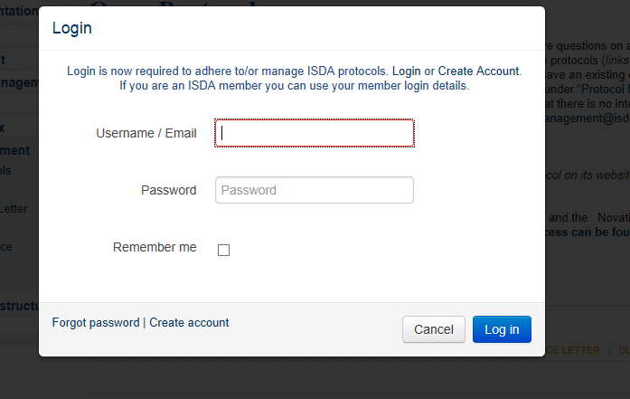

- Submit Adherence Letter: Form of adherence contains the information we need for each adhering party to generate an adherence letter. Below is a screenshot of the form and under is a description of the information we ask.

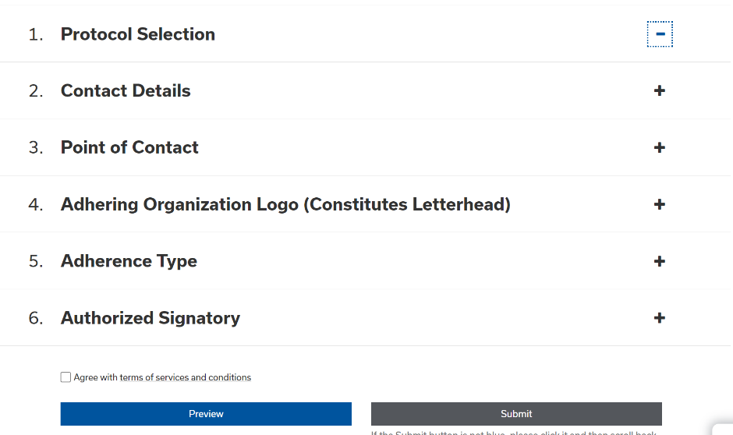

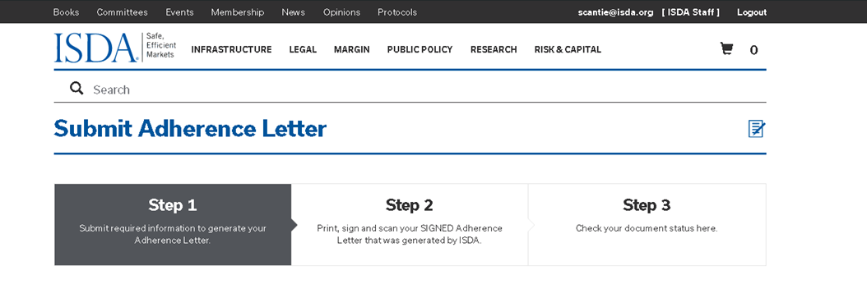

  - Contact Details: Please note that adherents to this protocol are required to provide an “official” contact email that will be publicly available with adherence information for the relevant entity on ISDA’s website. The general contact details here are separate and will not be made publicly available on ISDA’s website, however they will appear on the adherence letter that needs to be signed (but will be redacted in the adherence letter publicly available on the ISDA website). The system automatically populates the contact details of the person who has logged in. If you wish to enter different contact details please check the box “Clear Contact Details” and enter new details.

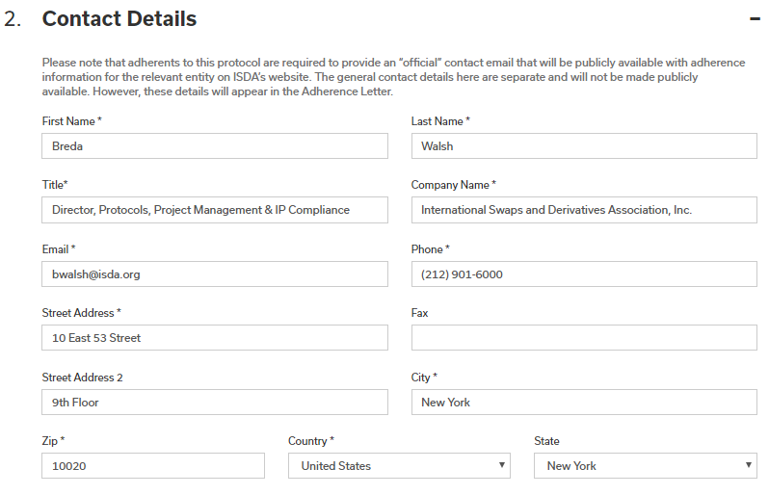

  - Point of Contact: ISDA sends emails to you at various points in the process, for example when you fill out the form and click “Submit”, a copy of the adherence letter that was generated will be emailed to this “Point of Contact”. In addition, you will receive email notifications when you pay the adherence fee, upload a signed letter, and also when your letter has been reviewed and accepted by ISDA and it is on the website.
  - Adhering Organization Logo: Adherence letters generally have the company’s logo on the top of the letter – we ask you to upload your institution’s logo in this section so that it can be used to generate your adherence letter. If you do not have a logo, you do not need to upload anything.

  - Adherence Type: You have four options from the dropdown, as shown below.
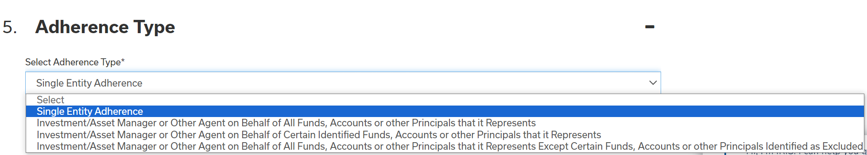

    - Single Reference Entity. If you are adhering on behalf of your firm only.
    - Three choices for Investment/Asset Managers and other Agents:
      - Investment/Asset Manager or Other Agent on Behalf of All Funds, Accounts or other Principals that it Represents. This option is used when you want to adhere all the funds, accounts or principals you represent. When you choose this option, you do not have to specify the funds on a Platform such as ISDA Amend. Your adherence letter is complete once the letter has been submitted.
      - Investment/Asset Manager or Other Agent on Behalf of Certain Identified Funds, Accounts or other Principals that it Represents. This option is used if you want to adhere specific funds to this protocol. An adhering party that uses this dropdown will need to identify these funds on a Platform such as the Agency Adherence Module on ISDA Amend. This Module is expected to go live mid-February 2024.
      - Investment/Asset Manager or Other Agent on Behalf of All Funds, Accounts or other Principals that it represents except Certain Funds, Accounts or other Principals Identified as Excluded. An adhering party that uses this dropdown will need to identify these funds on a Platform such as the Agency Adherence Module on ISDA Amend. This Module is expected to go live mid-February 2024.

    - You must enter the Organization Name and LEI or other identifier. An LEI is a “Legal Entity Identifier”. Additional information is available at https://www.leiroc.org/lei/how.htm. ISDA verifies the LEI so if you receive an error message, you should check the entity name and LEI you have entered for accuracy. If you do not see any errors and wish to proceed click “I confirm that I verified the organization name and identifier above”.

  - Authorized Signatory: This is someone who has signing authority for the organization. Note that ISDA requires an email address for this person individually.

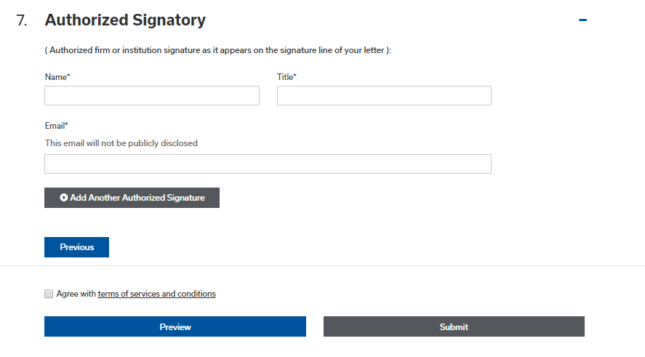

  - Agree with terms of services and conditions: These are ISDA’s standard terms and conditions for all protocols.
- Submit the form: This generates the conformed copy of the letter which will be emailed to the point of contact on the form. You will also be able to print the letter on the subsequent screen. Note that you have not yet adhered at this point. Please follow the remaining steps below.

- Manage Protocol Page: select the protocol you want to checkout under the “Choose Protocol” column. You can also:
  - Edit Adherence Letter: If you wish to make a change to the form you can go back in and edit the information on the form.
  - Submit Another Letter: This creates a new blank form and you can enter information for this or any other protocol.
  - Duplicate Letter: You can create a duplicate of the letter you just created. This create another letter with the same elections except the “Adherence Type” and “Authorized Signatory” information is not filled out.
  - Preview Adherence Letter: You can preview the letter and print it.
  - Delete Adherence: You can delete the letter.
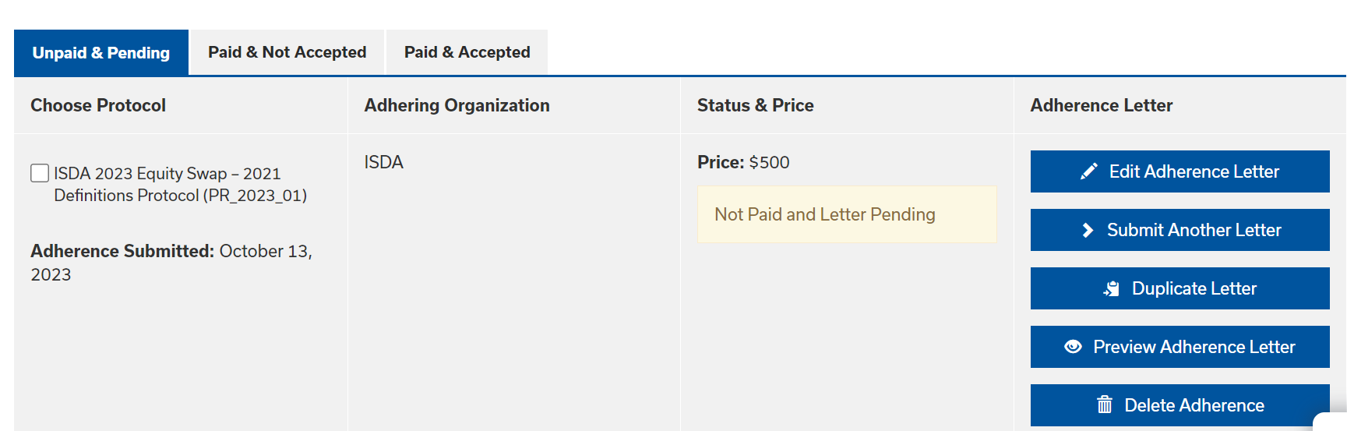

Scroll to the end of the page and choose “Proceed to Checkout”

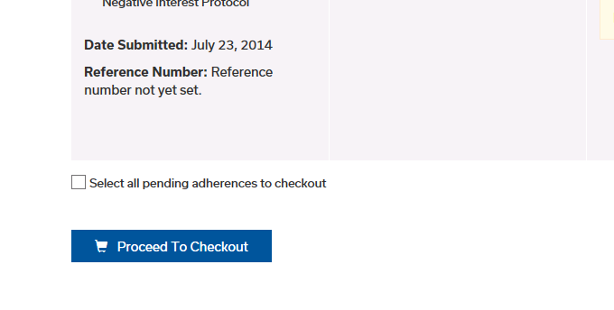

- Checkout Page: You will be asked for a credit card number for payment and we do not accept any other type of payment (wire, check or similar). NOTE: You cannot proceed with adherence without making the payment. If you are having problems making the payment, please contact protocolmanagement@isda.org.

    - TIER 1 AND TIER 2: ISDA offers pricing for multiple entity corporate and fund groups. Where a corporate or a fund group has 25 – 100 entities that adhere to a protocol, they can adhere for a flat fee of $12,500 (“Tier 1”). Where 100 or more entities from a group adhere, they can do so for a flat fee of $25,000 (“Tier 2”). If you qualify for this pricing please contact protocol protocolmanagement@isda.org for further details on how to make the payment and submit your adherence letters.
Looking up your Order: If at any point you close out of the process you can go back in and pick up where you left off by clicking on “Manage Protocols”.

- Print Letter(s): Print the letter(s) which need to be signed by the authorized signatory or you can use an electronic signature.

- Upload/Check Adherence Letter: Upload the signed letters below using the “browse” button to locate each one.

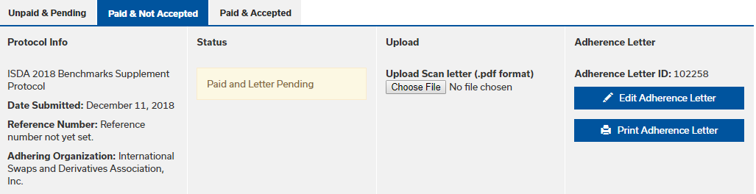

- Next, ISDA will review your letter(s):

  - If there are no issues, the adherence letter(s) will be “Accepted” in our system and this action will automatically upload your adherence letter to the ISDA website under “List of Adhering Parties” to the relevant protocol. Your adherence letter will also be available for viewing (but note that the contact details you provided above will be redacted). You will receive a system generated email (at the email you provided under “Point of Contact”) the moment this action takes place. The status of “Pending” shown below will change to “Accepted”.
  - If there is an issue with your letter – we will contact you and guide you through the steps to make corrections and successfully complete the process (it might be a typo, incomplete form or similar). The status below will change from “Pending” to “Rejected” and you will be given instructions on how to correct.
ISDA will endeavor to review your submitted letter within 24 hours of your submission but this will depend on volume and number of protocols open. The closer you leave it to any protocol adherence deadline the longer it will take to review.

- Email Notification: Once your letter(s) has been accepted you will receive an automated email (at the email you provided under “Point of Contact”) indicating this.

** If you have any additional questions contact: PROTOCOLMANAGEMENT@ISDA.ORG **

